

Requirement & Design Specification

**Easy Shop (EZShop)**

**Version: 1.0**

– Hanoi, January 2025 –

# Record of Changes

|  |  |  |  |  |
| --- | --- | --- | --- | --- |
| **Version** | **Date** | **A* M, D** | **In charge** | **Change Description** |
| V1.0 | 13/1 | A | MinhTN | Add System Context, Actors |
| V1.0 | 15/1 | A | VuongDM | Add Use Case Diagram, Use Case Description |
| V1.0 | 16/1 | A | VuongDM | Add Screens Flow, Screens authorization, Non-UI Functions |
| V1.0 | 20/1 | M | VuongDM | Update Use Case, Use Case Description |
| V1.0 | 22/1 | A | VuongDM | Add Diagram Schema, Table Descriptions |
| V1.0 | 3/2 | A | MinhTN | Add Package Diagram, User Authentication |
| V1.0 | 5/2 | M | VuongDM | Update User Case Diagram, Add functional requirement |
| V1.0 | 5/2 | M | MinhTN | Update Context Diagram, Package Diagram |
| V1.0 | 6/2 | A | VuongDM | Add functional requirement, table description database |
| v1.0 | 24/2 | M,D | VuongDM | Edit Functional Requirement, Delete package diagram and description |
| v1.0 | 25/2 | M | VuongDM | Edit package Diagram, package description |
| v1.0 | 27/2 | A | ChinhDQ | Add Functional Requirement( product list; productdetail) |
| v1.0 | 27/2 | A | MinhTN | Add Functional Requirement( registershop, Account List, Shop List) |
| v1.0 | 28/2 | A | VuongDM | Add Functional Requirement Seller ( Addproduct, Update Product, Productlist ) |
| v1.0 | 29/2 | A | ChinhDQ | Add Functional Requirement Seller ( View Shop Information, Edit Shop Information ) |
| v1.0 | 12/3 | M | VuongDM | Edit Use Case Diagram, Usecase Description |
| v1.0 | 15/3 | A | VuongDM | Add Functional Requirement Seller ( View Order List, View Order Detail, Shop information ) |
| v1.0 | 17/3 | A | MinhTN | Add Functional Requirement Admin, Customer |
| v1.0 | 17/3 | A | ChinhDQ | Add Functional Requirement Customer: cart, order |
| v1.0 | 25/3 | A,M,D | VuongDM | Edit RDS complete final |

*A - Added M - Modified D - Deleted

Contents

Record of Changes 2

I. Overview 4

1. System Context 4

2. User Requirements 4

2.1 Actors 4

2.2 Diagrams 5

2.3 Descriptions 6

3. System Functionalities 6

3.1 Screens Flow 6

3.2 Screen Authorization 6

3.3 Non-UI Functions 7

II. Functional Requirements 8

1. Feature Name1 8

1.1 SubFeature Name1.1 8

1.2 SubFeature Name1.2 8

2. User Authentication 8

2.1 User Register 8

2.2 User Login 8

2.3 Password Reset 8

2.4 User Profile 8

3. System Administration 9

3.1 Master Data 9

3.2 User Management 10

III. System Design 10

1. Database Design 10

1.1 Database Schema 10

1.2 Table Descriptions 10

2. Code Packages 11

2.1 Package Diagram 11

2.2 Package Descriptions 11

# I. Overview

## 1. System Context

The e-commerce platform system is a website that can help users buy products online at reasonable prices, providing users with the ability to create a store to post personal products for sale on the market. Users without an account can still view and look up products to buy. After confirming the order, the system will transfer the order to the seller for the seller to confirm and hand over to the shipping unit. In case the user transfers money in advance, the system will hold the money and after the user confirms that he has received the goods or after the specified time, the money will be transferred to the seller. The context diagram below illustrates the external entities and system interfaces for release 1.0.

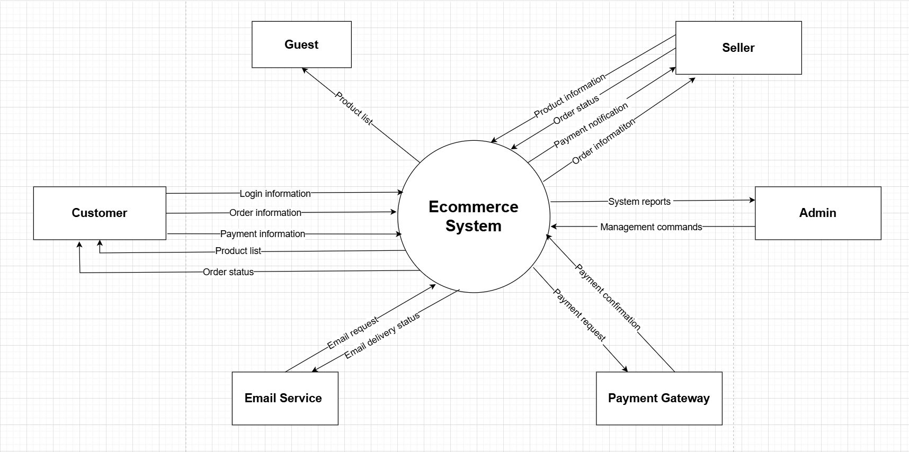

## 2. User Requirements

### 2.1 Actors

|  |  |  |
| --- | --- | --- |
| **#** | **Actor** | **Description** |
| 1 | Admin | is an e-commerce system role that is responsible for managing the system to ensure the system runs smoothly for buyers and sellers, and managing buyer and seller accounts. |
| 2 | Guest | is the role of a system user who can easily view and search for products in the e-commerce platform without having to log in. |
| 3 | Seller | is one of the important roles of the system by managing and posting your products for sale on the system so users can buy. |
| 4 | Customers | is an official user of the system, can buy products on the trading floor and can become a seller after registering a booth on the system. |

### 2.2 Diagrams

#### 2.2.1 UCs for Guest

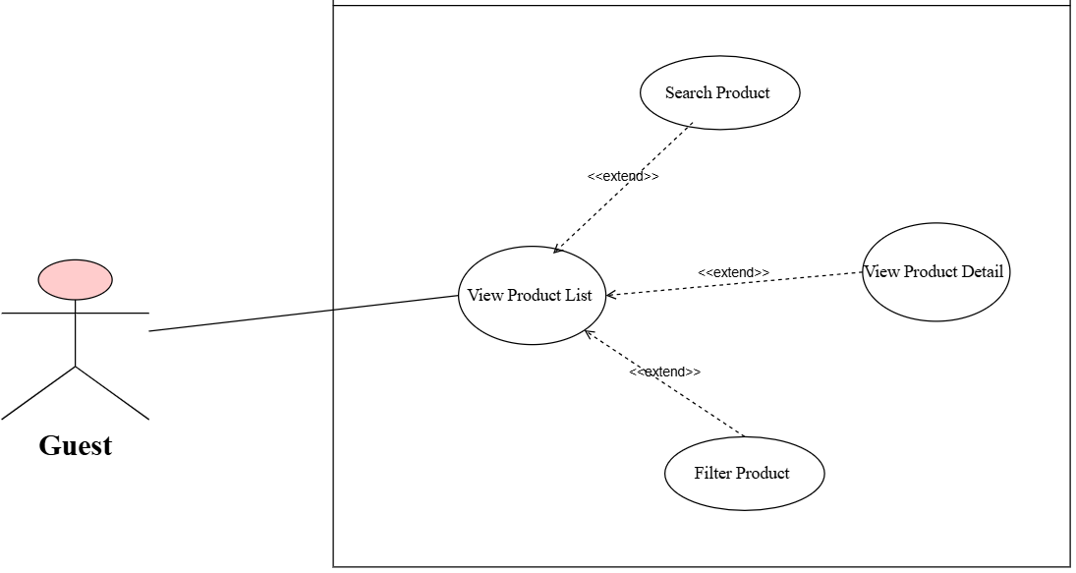

#### 2.2.1 UCs for Admin

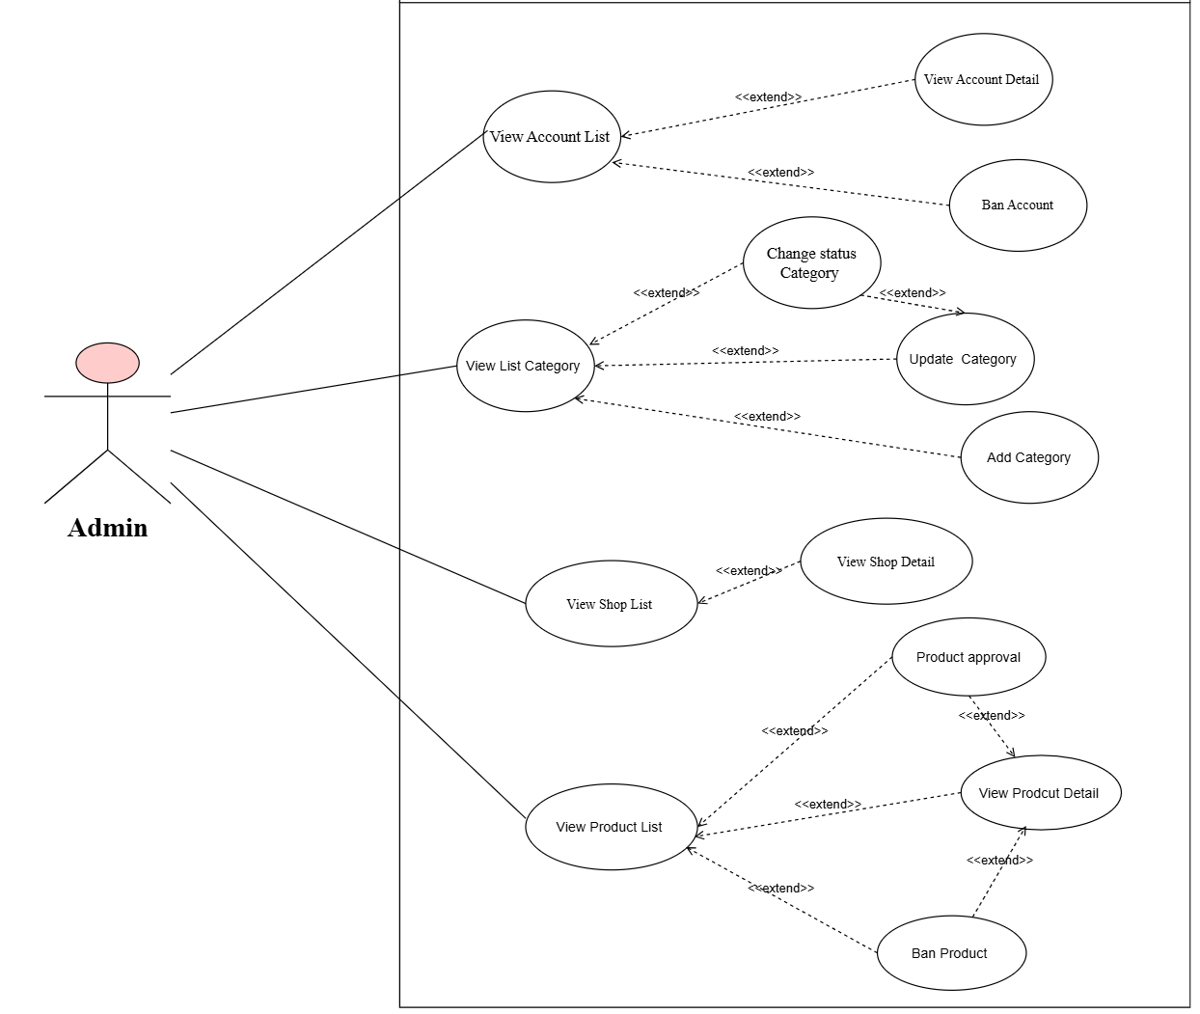

#### 2.2.1 UCs for Seller

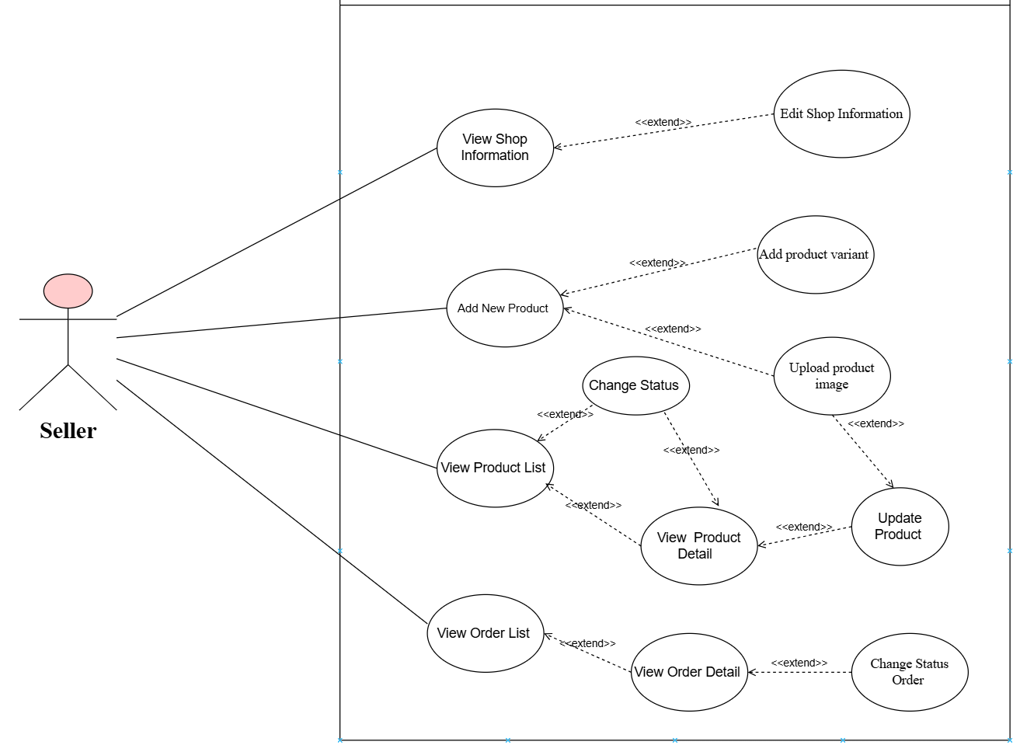

#### 2.2.4 UCs for Customer

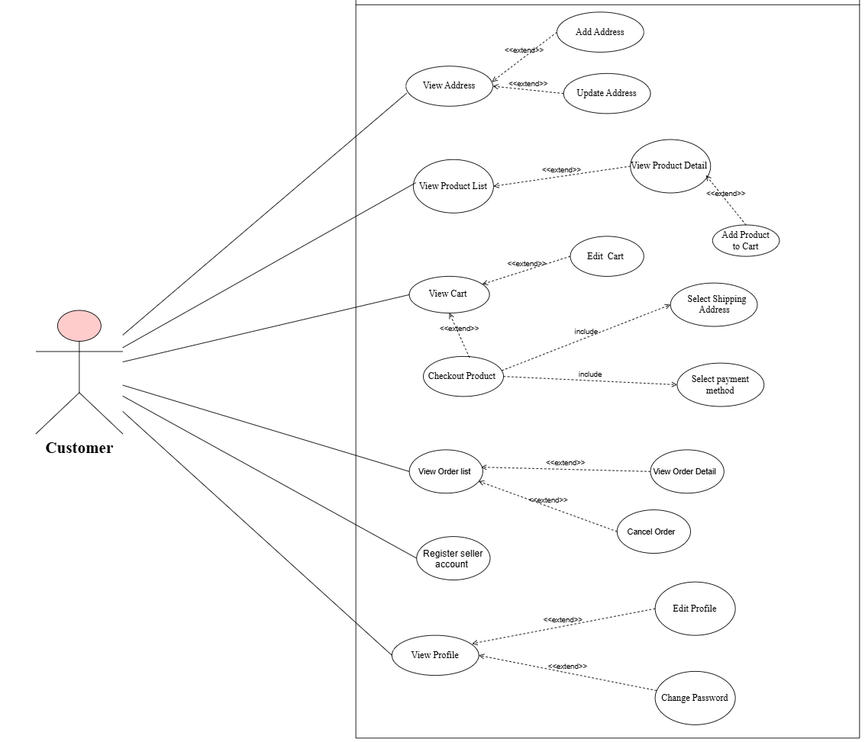

### 2.3 Descriptions

|  |  |  |  |
| --- | --- | --- | --- |
| **ID** | **Use Case** | **Actors** | **Use Case Description** |
| 01 | Login | Admin, Seller, Customer | A system that allows users to log into their accounts. |
| 02 | Register | Guest | Allows users to create a new account. |
| 03 | Forget Password | Admin, Seller, Customer | A feature that helps users recover their forgotten passwords. |
| 04 | Change Password | Admin, Seller, Customer | Allows users to change their passwords. |
| 06 | View Profile | Admin, Seller, Customer | Displays personal information of the user. |
| 07 | Update Profile | Admin, Seller, Customer | Allows users to update their personal information. |
| 08 | View Account List | Admin | Allows admin can view all list account of sellers and customers |
| 09 | View Detail Profile | Admin | Allows admin can view Profile of sellers and customers |
| 10 | Ban Account | Admin | Allows admin to ban seller's account for violations |
| 11 | View shop Information | Admin, Customer, Seller | Allows admin, customer, seller can view information of shop |
| 12 | Edit shop information | Admin | Allows seller can edit information of shop |
| 13 | View Product List | Admin | Allows admin to view product list sent by seller for approval or ban |
| 14 | View Product Detail | Admin | Allows admin to view product detail to approval or ban |
| 15 | Product approval | Admin | Approve the products sellers have added before posting them to the homepage |
| 16 | Ban Product | Admin | Allows admins to ban products that violate standards. |
| 17 | Add new Product | Seller | Enables sellers to add new products to the store. |
| 18 | Upload Product image | Seller | Allows sellers to upload images for products. |
| 19 | Add Category | Admin | Allow sellers to add products by category. |
| 20 | View List Category | Admin | Allow sellers can view category product list |
| 21 | Change status Category | Admin | Allow sellers can change status category product detail |
| 22 | Update Category | Admin | Enables sellers to edit existing categories. |
| 23 | View Product List in shop | Seller | Allow seller can view all product in shop |
| 24 | View Product Detail | Seller | Allow seller can view product details in shop |
| 25 | Update Product | Seller | Allows sellers to edit products to the store. |
| 26 | Add product variant | Seller | Adds variants, quantities and image, price of products for management. |
| 27 | View sales statistics | Seller | Seller can view sales statistics: total amount, sold products, remaining products... by date |
| 28 | Register seller account | Customer | Allows sellers can register for a sales account in system |
| 29 | View Address | Customer | Display information about the customer's address: Full name, phone number, specific address... |
| 30 | Add new Address | Customer | Customers can add information about their new address |
| 21 | Update Address | Customer | Customers can update information about their new address |
| 32 | Search Prodcut | Customer, Guest | Users can search for products in the store. |
| 33 | Filter Product | Customer, Guest | Users can filter the product list based on criteria. |
| 34 | View Product List | Customer, Guest | Allows users to view a list of all products. |
| 35 | View Product Detail | Customer, Guest | Allows users to view detailed information about products. |
| 36 | Add Product to Cart | Customer | Allows customers to add products to their shopping cart. |
| 37 | View Cart | Customer | Displays all products currently in the user's cart. |
| 38 | Edit Cart | Customer | Allows users to edit the shopping cart: add quantity,.... |
| 39 | Checkout Product | Customer | Enables customers to purchase and complete payment for items in their cart. |
| 40 | Select Shipping Address | Customer | Allows customer choose shipping address when order |
| 41 | Select Payment method | Customer | Allows customer choose payment method when order |
| 42 | View Order List | Customer | Displays a list of all orders placed by the user. |
| 43 | View Order Detail | Customer | Allows users to view detailed information about their orders. |
| 44 | View Shop List | Admin | Allow admin can view list shops in system |
| 45 | View Order List | Seller | Allows seller to view all order that the customer ordered |
| 46 | Change Status Order | Seller | Allows Seller Confirmation ordered |
| 47 | View Order Detail | Seller | Allows seller can view productvariant that the customer to order to approve |

## 3. System Functionalities

### 3.1 Screens Flow

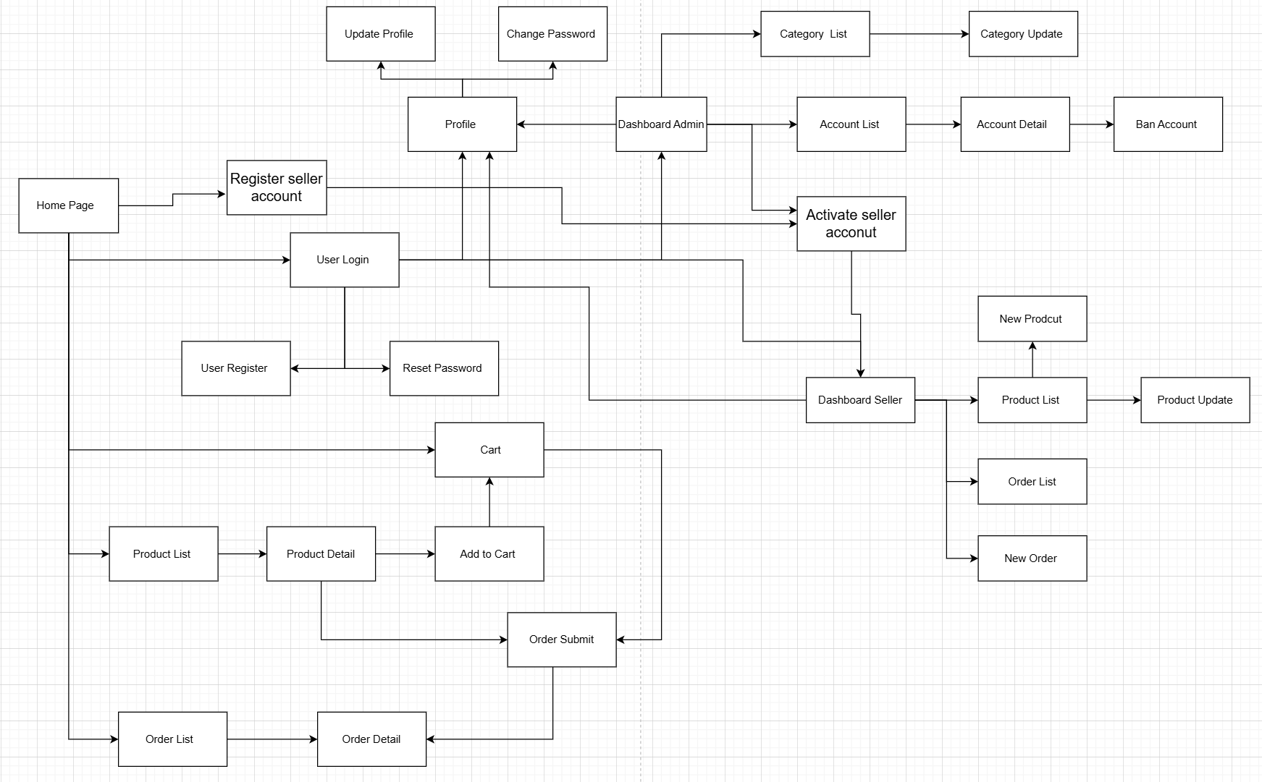

### 3.2 Screen Authorization

|  |  |  |  |  |
| --- | --- | --- | --- | --- |
| **Screen** | **Admin** | **Seller** | **Customer** | **Guest** |
| User Login | X | X | X |  |
| User Register |  |  |  | X |
| Forget Password | X | X | X |  |
| Change password | X | X | X |  |
| View Profile | X | X | X |  |
| Update Profile | X | X | X | X |
| View Address |  |  | X |  |
| Add new Address |  |  | X |  |
| View Account List | X |  |  |  |
| * Ban Account | X |  |  |  |
| View Account Detail | X |  |  |  |
| View shop Information | X | X | X | X |
| Edit shop information |  | X |  |  |
| View Order List |  | X |  |  |
| View Order Detail |  | X |  |  |
| * Order Confirm |  | X |  |  |
| Register seller account |  |  | X |  |
| View Product List in shop |  | X |  |  |
| Add new Product |  | X |  |  |
| Update Product |  | X |  |  |
| Change status Product |  | X |  |  |
| * Add product variant |  | X |  |  |
| * Upload product image |  | X |  |  |
| View Category |  | X |  |  |
| * Add Category | X |  |  |  |
| * Update Category | X |  |  |  |
| * Change status Category | X |  |  |  |
| Home Page |  |  | X |  |
| * View Product List |  |  | X | X |
| * Search Product |  |  | X | X |
| * Filter Product list |  |  | X | X |
| View Product detail |  |  | X | X |
| Add product to cart |  |  | X |  |
| View Cart |  |  | X |  |
| * Edit Cart |  |  | X |  |
| * Delete product in cart |  |  | X |  |
| Order Product |  |  |  |  |
| * Select Shipping Address |  |  | X |  |
| * Select payment method |  |  | X |  |
| View order list |  |  | X |  |
| View order detail |  |  | X |  |
| Track order |  |  | X |  |
| View Shop List | X |  |  |  |
| View Product List | X |  |  |  |
| View Product Detail | X |  |  |  |
| * Product approval | X |  |  |  |
| * Ban product | X |  |  |  |

### 3.3 Non-UI Functions

|  |  |  |  |
| --- | --- | --- | --- |
| **#** | **Feature** | **System Function** | **Description** |
| 1 | Authorization | LogiLogin | Distinguish between Admin, Seller, Customer. |
| 2 | Account security | ChangePassword | Send OTP to users to get confirmation code when changing password. |
| 3 | Inventory Management | Order | Automatically deduct quantity when there is an order. |
| 4 | Scalability | Server & database systems | The system can be expanded as the number of users increases. |
| 5 | Reliability & Fault Tolerance | Anti-error system | Automatically redirect when a server fails (Load Balancing).  Regularly backup data to avoid losing important information. |

# II. Functional Requirements

## 1. User Authentication

### 1.1 User Register

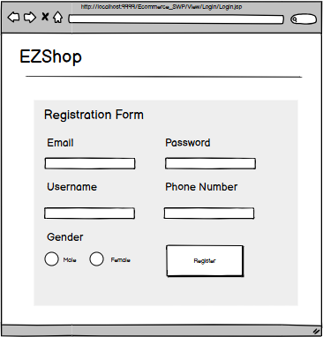

This screen allows the Guest to:

* Allow guests to register an account to login to the system.

**Field Description**

|  |  |
| --- | --- |
| **Field Name** | **Description** |
| Username | Data type: string |
| Password | Data type: String with at least a upper letter, a special symbol, a number and a letters |
| Email | Data type: any string, length of 6-254 characters with a @ symbol |
| Phone number | Data type: No alphabetic characters, 10 numbers |
| Gender | Data type: boolean, auto select male |

### 1.2 User Login

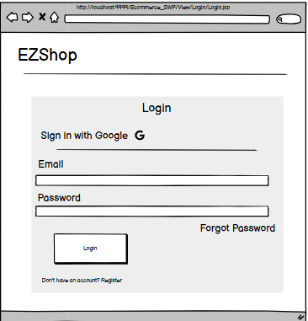

This screen allows the Guest to:

* Login into the system by google or username and password.

**Field Description**

|  |  |
| --- | --- |
| **Field Name** | **Description** |
| Username | Data type: string |
| Password | Data type : String with at least a upper letter, a special symbol, a number and a letters |

### 1.3 User Profile

#### 1.3.1 User View Profile

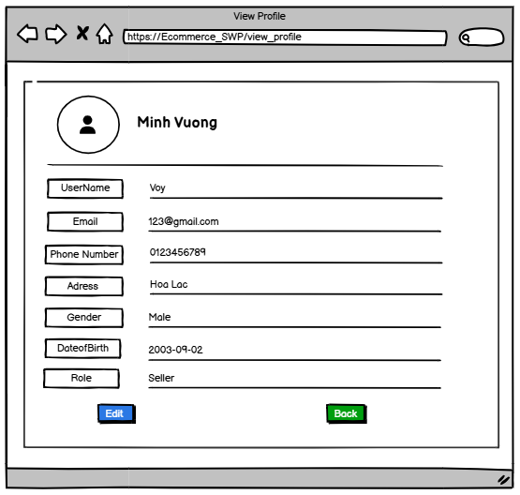

This screen allows the User to: View individual information

|  |  |
| --- | --- |
| **Field Name** | **Description** |
| First Name | Data type: any string, max length of 20 characters |
| Last Name | Data type: any string, max length of 20 characters |
| Email | Data type: any string, length of 6-254 characters |
| Phone Number | Data type: No alphabetic characters, 10 numbers |
| AddresAddress | Data type: any string, max length of 100 characters |
| Gender | Data type: select a gender |
| Date of birth | Data type: format mm/dd/yyyy |
| Role | Data type: any string |
| Edit | Button to go to the Edit profile page |

#### 1.3.2 User Edit Profile

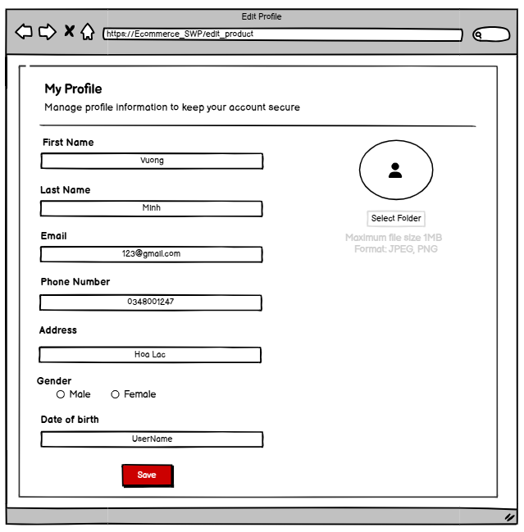

This screen allows the User to: Update individual information including fields and photos.

**Field Description**

|  |  |
| --- | --- |
| **Field Name** | **Description** |
| First Name | Data type: any string, max length of 20 characters |
| Last Name | Data type: any string, max length of 20 characters |
| Email | Data type: any string, length of 6-254 characters |
| Phone Number | Data type: No alphabetic characters, 10 numbers |
| AddresAddress | Data type: any string, max length of 100 characters |
| Gender | Data type: select a gender |
| Date of birth | Data type: format mm/dd/yyyy |
| Save | Button to save information after input |

### 1.4 Forgot Password

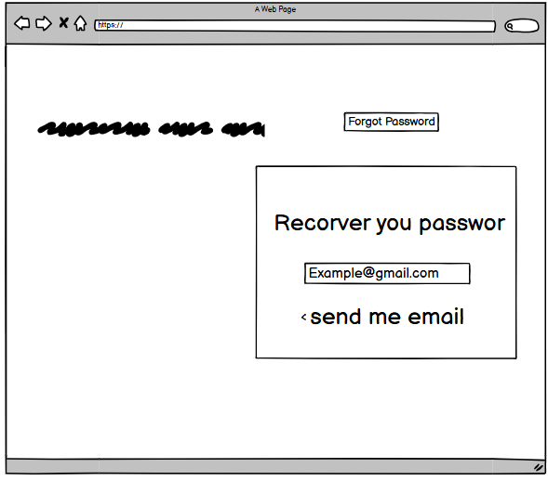

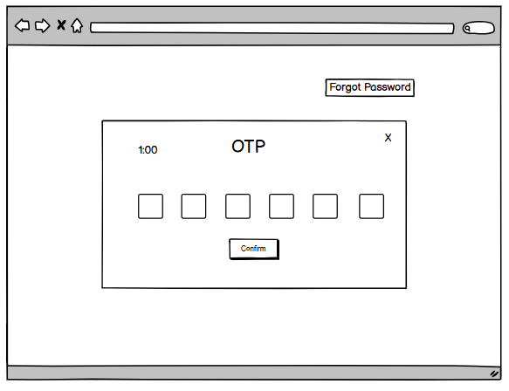

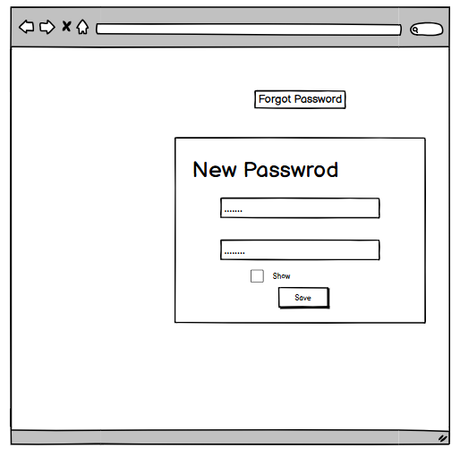

This screen allows the User to:3 screens to perform the steps to recover your password.

|  |  |
| --- | --- |
| **Field Name** | **Description** |
| Email | Data type: any string, length of 6-254 characters with a @ symbol |
| OTP | Data type: No alphabetic characters, 6 numbers |
| New Password | Data type: Data type : String with at least a upper letter, a special symbol, a number and a letters |
| Confirm | Data type: same as new password |

### 1.5 Change Password

|  |  |
| --- | --- |
| **Field Name** | **Description** |
| Current password | Data type: String (re-enter your old password) |
| New Password | Data type: String with at least a upper letter, a special symbol, a number and a letters |
| Repeat Password | Data type: same as new password |

## 2. Customer

### 2.1 Register Shop

### 

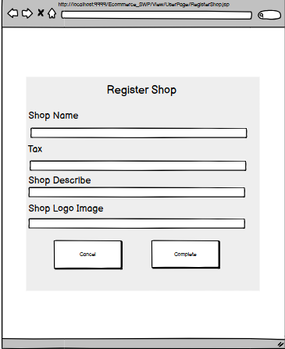

This screen allows the User to Register a shop to become a seller:

**Field Description**

|  |  |
| --- | --- |
| **Field Name** | **Description** |
| Shop Name | Name of the retail establishment or business as it appears to customers |
| Tax | Tax identification number or business registration number for financial reporting |
| Shop Describe | Detailed description of the shop including its specialty, products offered, and other relevant business information |
| Shop Logo Image | Upload field for the shop's brand logo or image representation (supported formats: JPG, PNG, SVG) |

### 2.2 View Product

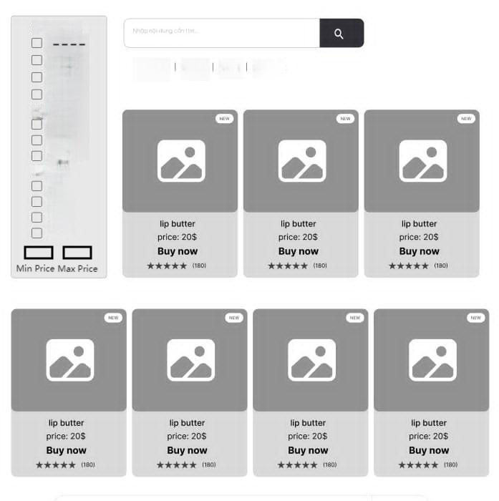

This screen allows the customer:see product list

|  |  |
| --- | --- |
| **Field Name** | **Description** |
| Seach | Data type: any string, length of 6-254 characters(search the name of the product) |
| Checkbox | checkbox(filter options) |
| Min Price | Data type: float |
| Max Price | Data type: float |

### 

### 

### 2.3 View Product detail

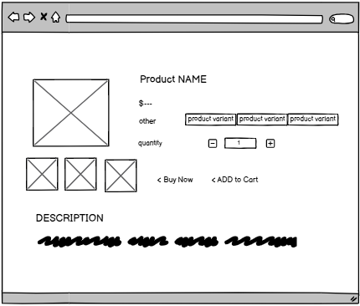

This screen allows the customer:see product detail

|  |  |
| --- | --- |
| **Field Name** | **Description** |
| Product variant | button : Select the desired product type |
| (-,+) button | The button must not exceed the allowable limit of the product and must not emit sound. |
| Buy Now | Button: redirect to payment (conditions to choose product variant) |
| Add to cart | Button: move product to cart(conditions to choose product variant) |

### 

### 2.4 Cart This screen allows the customer: Shopping Cart

|  |  |
| --- | --- |
| **Field Name** | **Description** |
| DELETE | button : Delete product |
| (-,+) button | The button must not exceed the allowable limit of the product and must not emit sound. |
| Buy Now | Button: redirect to payment (conditions to choose product variant) |
| Checkout | Button: Check selected products |
| All select(Delete) | Button: Delete all selected products |

### 

### 2.5 View address list

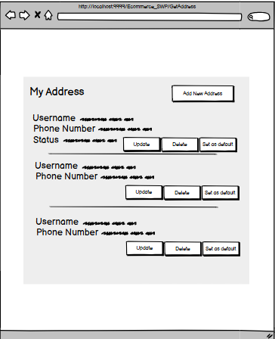

This screen allows the customer: Get Address

|  |  |
| --- | --- |
| **Field Name** | **Description** |
| Username | Data type:String (User username) |
| Phone Number | Data type: String (User phone number) |
| Status | Data type: boolean (User default address) |
| Update | Button: Update address |
| Delete | Button: Delete address |
| Set as default | Button: Set address as default |
| Add New Address | Button: Add new address |

### 

### 2.6 Add address

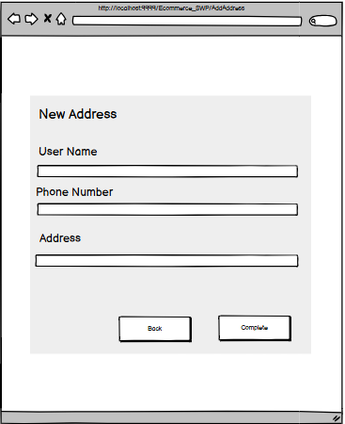

This screen allows the customer:

|  |  |
| --- | --- |
| **Field Name** | **Description** |
| Username | Data type:String (User username) |
| Phone Number | Data type: String (User phone number) |
| Address | Data type: String(User address) |
| Back | Button: Cancel add address |
| Complete | Button: Complete add address |

### 

### 2.7 Update address

### 

This screen allows the customer:

|  |  |
| --- | --- |
| **Field Name** | **Description** |
| Username | Data type:String (User username) |
| Phone Number | Data type: String (User phone number) |
| Address | Data type: String(User address) |
| Cancel | Button: Cancel update address |
| Save Change | Button: Complete update address |

### 2.8 Checkout Product Selected In Cart

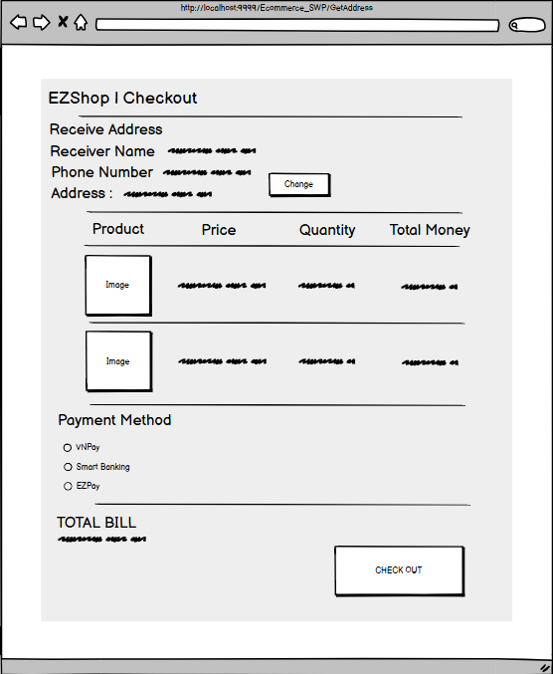

### This screen allows the customer: Shopping Cart

|  |  |
| --- | --- |
| **Field Name** | **Description** |
| Receiver Name | Data type:String (user receiver name) |
| Phone Number | Data type: String (User phone number) |
| Address | Data type: String(User address) |
| Product | Data type: Image (Product variant image) |
| Price | Data type: Float(Product variant price) |
| Quantity | Data type: Int(Product checkout quantity) |
| Total Money | Data type: Float(Price of each product variant multiple with quantity) |
| Payment Method | Data type: String(Payment method name) |
| Total bill | Data type: Float(Price of all total money) |
| Check out | Data type: button(Confirm check out product) |

### 

### 

### 

### 

### 

### 2.9 View Order Detail

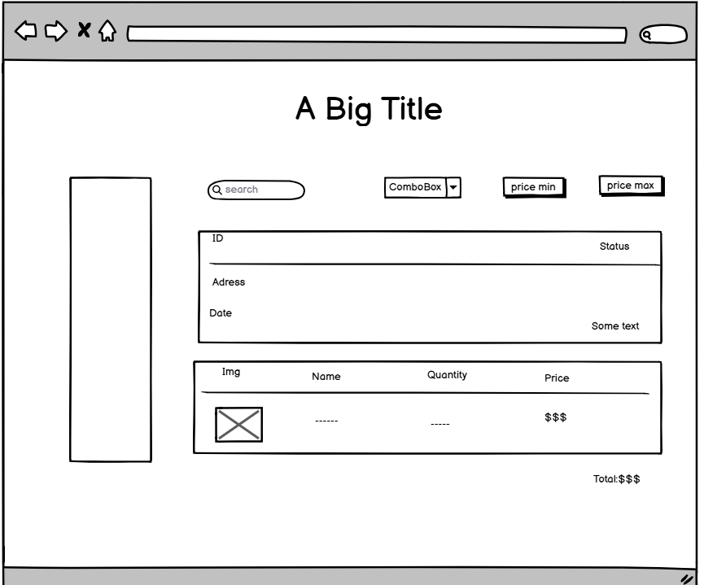

This screen allows the customer: Shopping Cart

|  |  |
| --- | --- |
| **Field Name** | **Description** |
| Seach | Data type:String (Search for purchased products) |
| Combobox | Select:state of order |
| Price Min | Button: product arrangement |
| Price Max | Button:product arrangement |

### 

## 3. Admin Management

### 3.1 Admin Manage Account

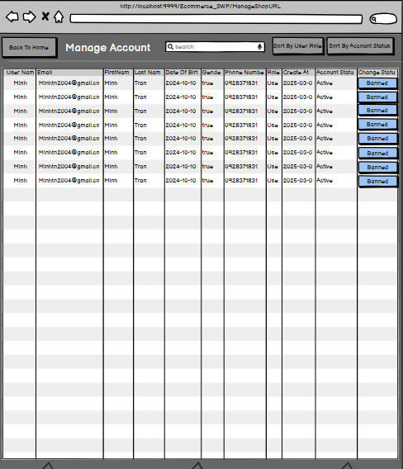

This screen allows the Administrator to:

* View Account List: Allow Administrator see list of accounts with user data.
* Sort Setting List: filter user data by user role or account status
* Search Settings: enter keyword(s) to search user data by their names or email

On the screen, s/he can also

* Ban/Active Setting: change status of a specific ban/active user data

**Field Description**

|  |  |
| --- | --- |
| **Field Name** | **Description** |
| User Name | Username for system login, must be unique and cannot be blank or duplicate an existing username |
| Email | User's email address for account verification and communications, must be in valid email format |
| First Name | User's given name as it appears on identification documents and in the system interface |
| Last Name | User's family name or surname as it appears on identification documents and in the system interface |
| Date Of Birth | User's date of birth in day/month/year format |
| Gender | User's gender information (Male, Female, Other) |
| Phone Number | User's contact phone number including area code if necessary |
| Role | User's role or position within the system (Admin, User, Manager, etc.) |
| Create At | Account creation timestamp, automatically recorded in day/month/year hour:minute format |
| Account Status | Current status of the user account (Active, Suspended, Deleted) |
| Change Status | Button allowing status changes between different account states |

### 3.2 Admin Manage Shop

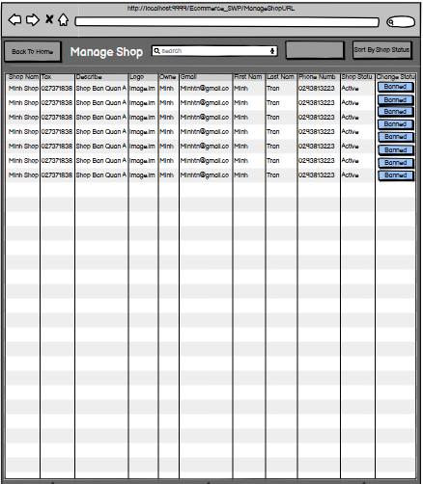

This screen allows the Administrator to:

* View Shop List: Allow Administrator see list of shops with user data.
* Sort Setting List: filter shop data by shop status or shop name
* Search Settings: enter keyword(s) to search user data by their Shop Name or email

On the screen, admin can also

* Ban/Active Setting: change status of a specific ban/active shop data

**Field Description**

|  |  |
| --- | --- |
| **Field Name** | **Description** |
| Shop Name | Name of the retail establishment or business as it appears to customers |
| Tax | Tax identification number or business registration number for financial reporting |
| Describe | Brief description of the shop, its products, services, or specialty |
| Logo | Shop's brand image or logo file (supports common image formats like JPG, PNG, SVG) |
| Gmail | Primary email address associated with the shop for communications and notifications |
| First Name | Shop owner's or primary contact's given name |
| Last Name | Shop owner's or primary contact's family name or surname |
| Phone Number | Contact phone number for the shop including area code if necessary |
| Shop Status | Current operational status of the shop (Active, Inactive, Under Review, etc.) |
| Change Status | Button allowing administrators to modify the shop's current status |

### 3.3 View list category

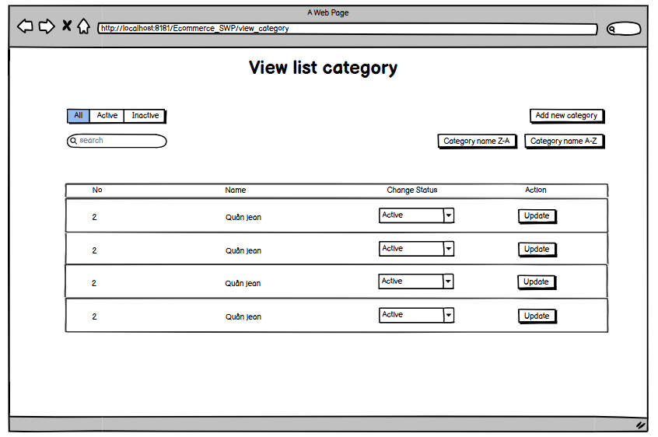

|  |  |
| --- | --- |
| **Field Name** | **Description** |
| Search | Category search field by category name |
| Add new Category | Button to to go to the add new products page |
| Name | Category name of the product in the system |
| Change Status | The field selects the status of the product category |
| Action | Button to update the list in the system |

### 3.4 Add new category

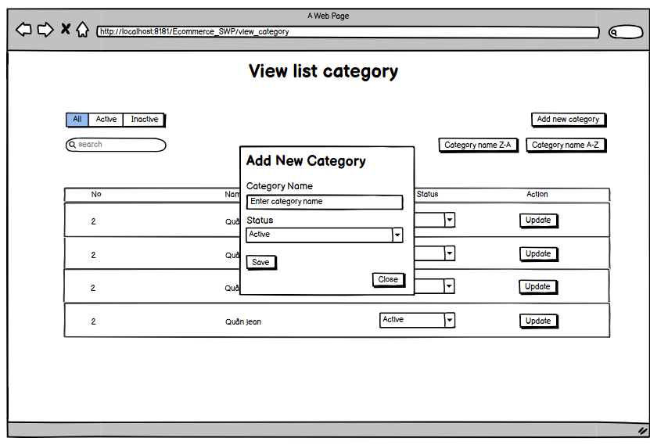

|  |  |
| --- | --- |
| **Field Name** | **Description** |
| Search | Category search field by category name |
| Category Name | Category name of the product in the system. length 2- 50 , not same another name |
| Status | The field selects the status of the product category |
| Save | Button to save category after updating |
| Close | Button to close the modal add update category |

### 3.5 Update category

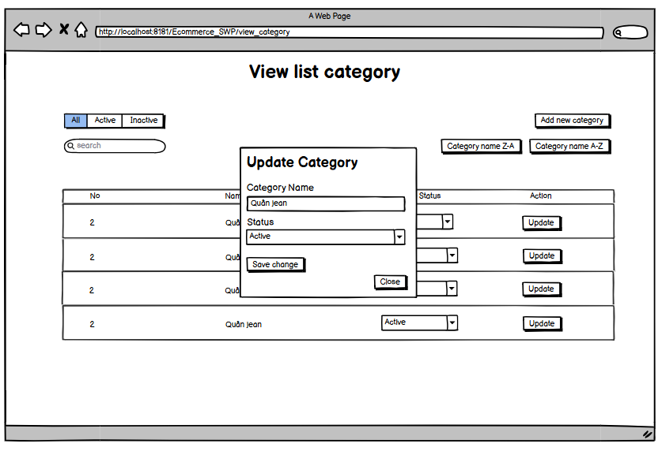

## 

|  |  |
| --- | --- |
| **Field Name** | **Description** |
| Search | Category search field by category name |
| Category Name | Category name of the product in the system. length 2- 50, not same another category |
| Status | The field selects the status of the product category |
| Save | Button to save category after adding |
| Close | Button to close the modal add new category |

### 3.6 View Product List

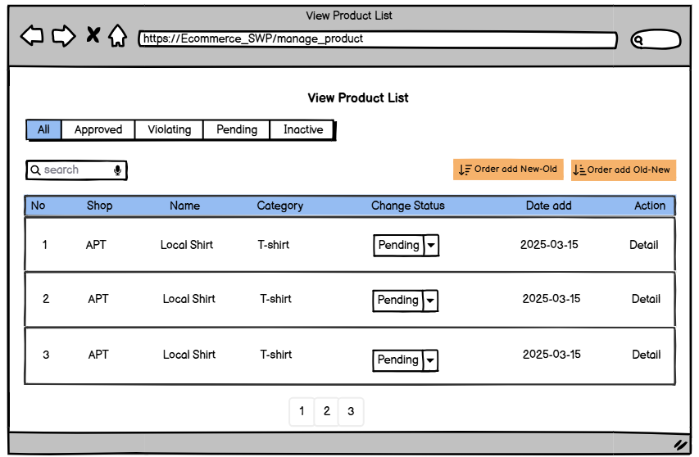

|  |  |
| --- | --- |
| **Field Name** | **Description** |
| Search | search field by category name |
| Category Name | Category name of the product in the system. |
| Shop | Name Shop send product post to the system |
| Name | Field Product Name that the Seller post |
| Change status | Field Change status of product: pending, approve,ban |
| Date add | Date product was sent for approval |
| Action | Button Detail when click will go to page view Product Detail |

### 3.7 View Product Detail

This screen allows the Admin to:

* View store list: Allows the Admin to view product details when the shop is added to the system

On this screen, the Admin can also

* Set ban/activate: Approve or reject products if they violate

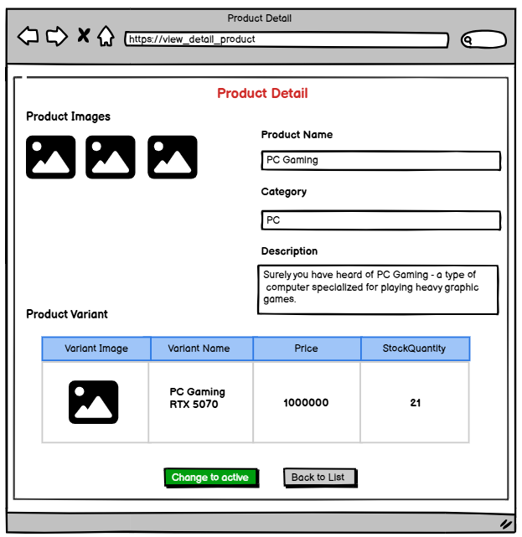

|  |  |
| --- | --- |
| **Field Name** | **Description** |
| Product Name | Field name of product seller sent |
| Category | Field name of product seller sent |
| Description | Field Description of product seller sent |
| Variant Image | Field Product Variant image of product |
| Variant Name | Field Product Variant name of product |
| Price | Field Price of product variant |
| StockQuantity | Field StockQuantity of Product Variant Seller add |
| Change to active | Button change status of product: approve,ban |
| Back to list | Button when click will return page product list of admin |

### 3.8 Add payment method

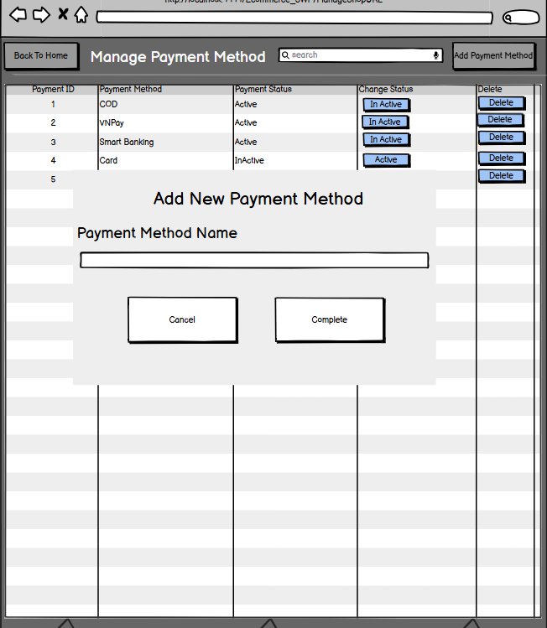

|  |  |
| --- | --- |
| **Field Name** | **Description** |
| Payment Method Name | Data type: String(Payment method name) |
| Cancel | Data type: button(Cancel add payment method) |
| Complete | Data type: button(Complete add payment method) |

### 3.9 Manage Payment Method

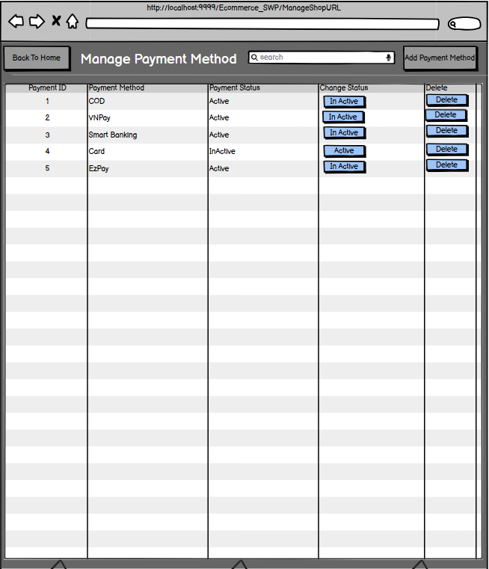

|  |  |
| --- | --- |
| **Field Name** | **Description** |
| Payment ID | Field data of payment id |
| Payment Method | Field name of payment method |
| Payment Status | Field status of payment method |
| Change Status | Field Button Change Payment method status |
| Delete | Field Delete button to delete payment method |

## 4. Seller

### 4.1 Seller View Product List

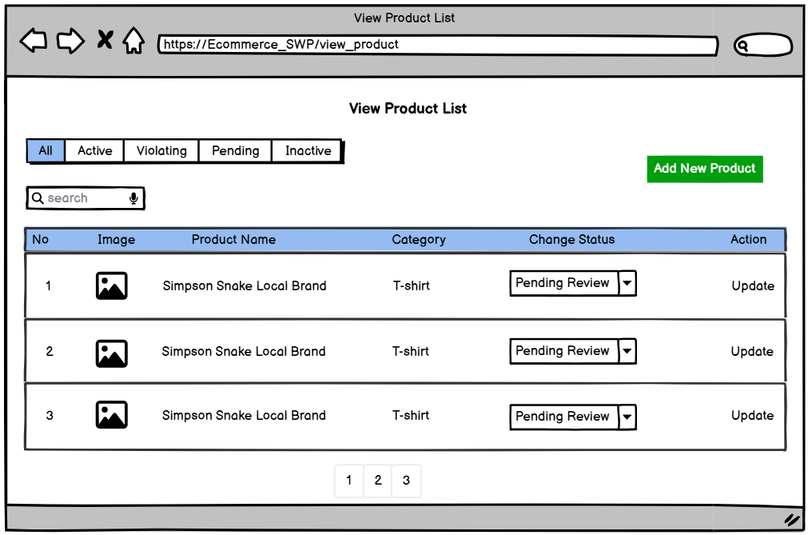

|  |  |
| --- | --- |
| **Field Name** | **Description** |
| Image | Field to upload product images or files related to the product. |
| Name | The name of the product, representing the main item being sold. |
| Category | Categories of products. The classification of the product, helping organize products into relevant sections. |
| Change Status | Select field to change the product's status |
| Action | Button to update product to the system. |
| Add New Product | Button to add a new product to the system. |
| New Product | Button to to go to the add new products page |

### 4.2. Seller Add Product

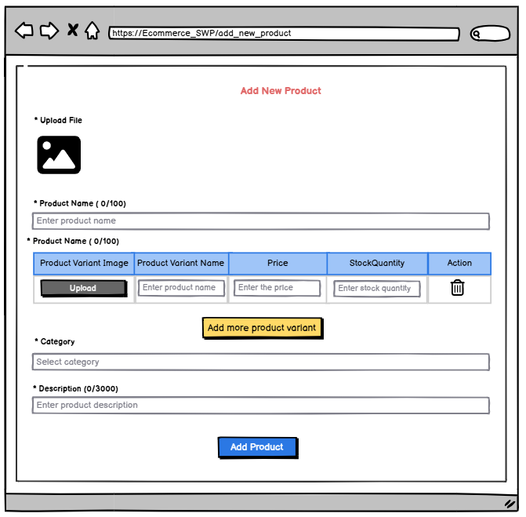

|  |  |
| --- | --- |
| **Field Name** | **Description** |
| Upload Field | Field to upload product images or files related to the product. |
| Product Name | The name of the product, representing the main item being sold. |
| Product Variant | A specific variation of the product, such as different sizes, colors, or models. |
| Product Variant Image | An image representing a specific variant of the product. |
| Product Variant Name | The name of a particular product variant, distinguishing it from other variations. |
| Price | The selling price of the product or its variant. |
| Stock Quantity | The available inventory for the product or its specific variant. |
| Action | Buttons or controls for editing, deleting, or managing the product or its variants. |
| Add more product variant | Option to add additional product variations, such as different colors or sizes. |
| Category | The classification of the product, helping organize products into relevant sections. |
| Description | A detailed explanation or specifications of the product. |
| Add Product | Button to add a new product to the system. |

### 4.3 Seller Update Product

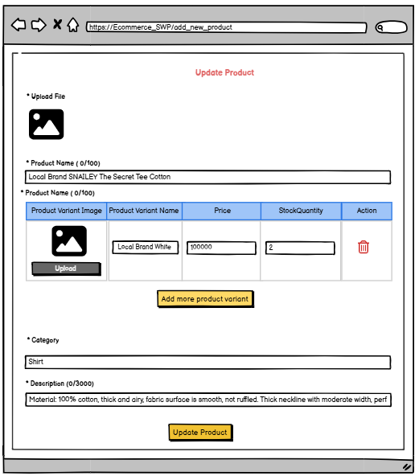

|  |  |
| --- | --- |
| **Field Name** | **Description** |
| Updaload Field | Field to upload product images or files related to the product. |
| Product Name | The name of the product, representing the main item being sold. |
| Product Variant | A specific variation of the product, such as different sizes, colors, or models. |
| Product Variant Image | An image representing a specific variant of the product. |
| Product Variant Name | The name of a particular product variant, distinguishing it from other variations. |
| Price | The selling price of the product or its variant. |
| Stock Quantity | The available inventory for the product or its specific variant. |
| Action | Buttons or controls for editing, deleting, or managing the product or its variants. |
| Add more product variant | Option to add additional product variations, such as different colors or sizes. |
| Category | The classification of the product, helping organize products into relevant sections. |
| Description | A detailed explanation or specifications of the product. |
| Update Product | Button to update product to the system. |

### 4.4 Seller Manager Shop

#### 4.4.1 Seller View Shop Information

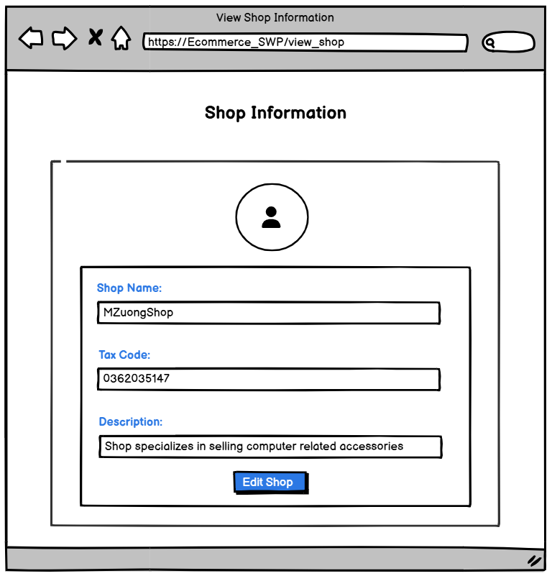

|  |  |
| --- | --- |
| **Field Name** | **Description** |
| Shop Name | Data type: any string, length of 1-254 characters |
| Tax Code | Data type: No alphabetic characters, 10 or 13 numbers |
| Description | Data type: any string, length of 1-254 characters |
| Edit Shop | Buttom when click will go to the edit shop screen. |

#### 4.4.2 Seller Edit Information

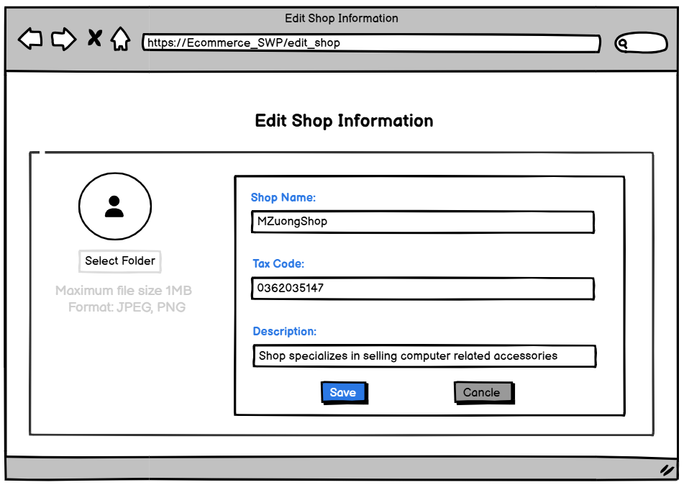

|  |  |
| --- | --- |
| **Field Name** | **Description** |
| Shop Name | Data type: any string, length of 1-254 characters |
| Tax Code | Data type: No alphabetic characters, 10 or 13 numbers |
| Description | Data type: any string, length of 1-254 characters |
| Select Folder | Select image from library, size<1MB, type: JPEG,PNG |
| Save | Button to save after change information shop |
| Cancel | Button cancel if no save information |

### 4.5 Seller View List Order

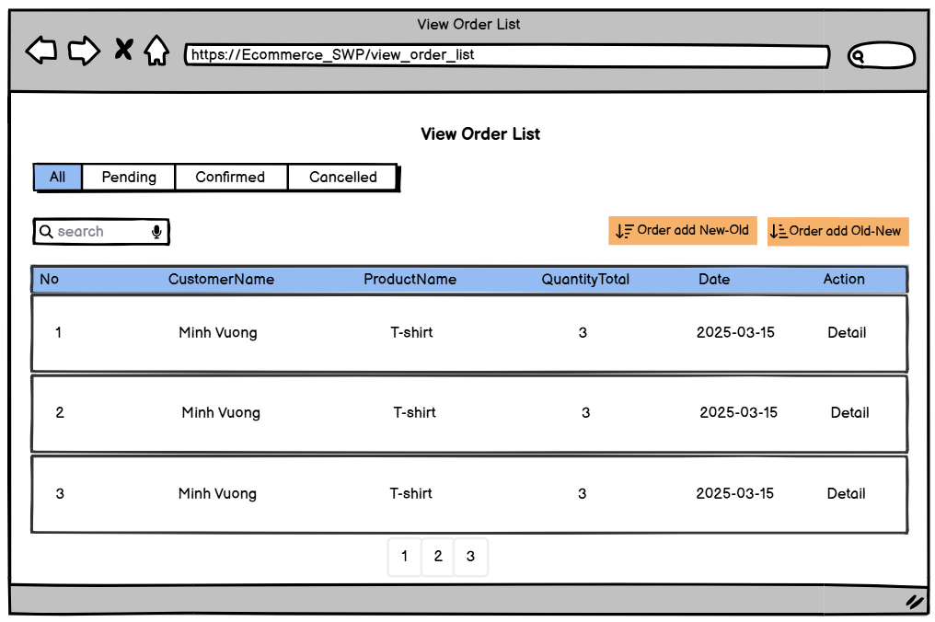

|  |  |
| --- | --- |
| **Field Name** | **Description** |
| Search | Search by product name |
| CustomerName | Name of Customer ordered |
| ProductName | Name of Product that the customer ordered |
| QuantityTotal | Total number of products ordered by customer |
| Date | Price of ProductVariant that the customer ordered |
| Action | Button Detail when click will give detail ordered |

### 4.6 Seller View Order Detail

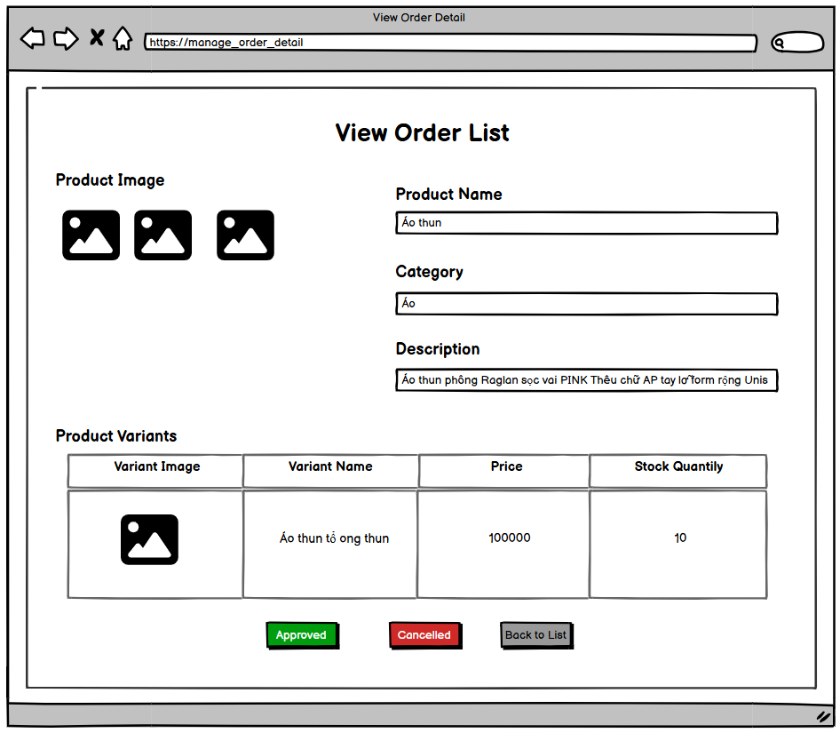

|  |  |
| --- | --- |
| **Field Name** | **Description** |
| Product Image | Field image of product that customer order |
| Product Name | Field name of product that customer order |
| Category | Field name of category product that customer order |
| Description | Field Description of product that customer order |
| Variant Image | Field Product Variant image of product |
| Variant Name | Field Product Variant name of product |
| Price | Field Price of product variant |
| Stock Quantity | Field Stock Quantity of product variant |
| Approved | Button approved to approve order |
| Cancelled | Button cancel to cancel order |
| Back To List | Button when click will return order list |

### 

# III. System Design

## 1. Database Design

### 1.1 Database Schema

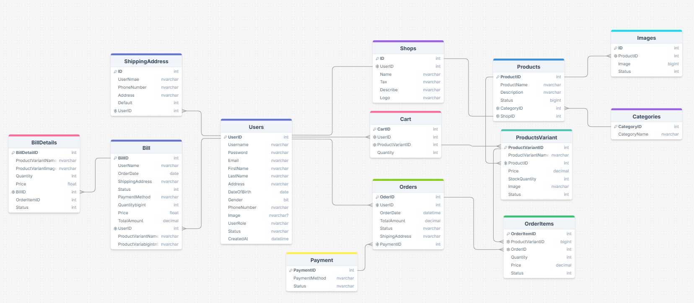

### 1.2 Table Descriptions

|  |  |  |
| --- | --- | --- |
| **No** | **Table** | **Description** |
| 01 | <Table Users> | **Description of the table**: Stores user information, including login details, contact information, and roles.   * **Primary keys**: UserID * **Foreign keys**: None * **Unique keys**: Username, Email |
| 02 | <Table ShippingAddress> | **Description of the table**: Stores multiple shipping addresses for users, allowing users to set a default address.   * **Primary keys**: id * **Foreign keys**: userId (References Users(UserID)) * **Unique keys**: None |
| 03 | <Table Shops> | **Description of the table**: Stores information about individual shops registered on the platform, including tax details and shop logo.   * **Primary keys**: ID * **Foreign keys**: UserID * **Unique keys**: userId (Each shop is associated with a unique user) |
| 04 | <Table Products> | **<Table Products>** **Description of the table**: Stores general information about a product, a product may have many different variations or details.   * **Primary keys**: ProductID * **Foreign keys**: CategoryID, ShopID * **Unique keys**: None |
| 05 | <Table Categories> | **<Table Categories>** **Description of the table**: Stores product categories, which can have parent-child relationships.   * **Primary keys**: CategoryID * **Foreign keys**: None * **Unique keys**: None |
| 06 | <Table image> | **<Table Images>** **Description of the table**: Stores product images linked to the Products table.   * **Primary keys**: ID * **Foreign keys**: ProductID * **Unique keys**: None |
| 07 | <Table Order> | **<Table Orders>** **Description of the table**: Stores user order details, including order status and payment method.   * **Primary keys**: OrderID * **Foreign keys**: UserID * **Unique keys**: None |
| 08 | <Table OrderItems> | **Description of the table**: Stores the list of products included in a specific order.   * **Primary keys**: OrderItemID * **Foreign keys**: OrderID, ProductID * **Unique keys**: None |
| 09 | <Table Cart > | **<Table Cart>** **Description of the table**: Stores shopping cart details for users, linking users to selected products.   * **Primary keys**: CartID * **Foreign keys**: UserID, ProductID * **Unique keys**: None |
| 10 | <Table Payment> | **<Table Payment>** **Description of the table**: Stores payment details for each order.   * **Primary keys**: PaymentID * **Foreign keys**: OrderID * **Unique keys**: None |
| 13 | <Table ProductVariants> | **Description of the table**: Stores information about versions or variations of a product, usually by color, quantity, image.   * **Primary keys**: ProductVariantID * **Foreign keys**: ProductID * **Unique keys**: None |
| 14 | <Table Bill > | **Description of the table**: Stores information about history order   * **Primary keys**: BillID * **Foreign keys**: UserID * **Unique keys**: None |
|  | <Table BillDetail > | **Description of the table**: Stores information about history order detail   * **Primary keys**: BillDetailID * **Foreign keys**: BillID * **Unique keys**: None |

## 2. Code Packages

### 2.1 Package Diagram

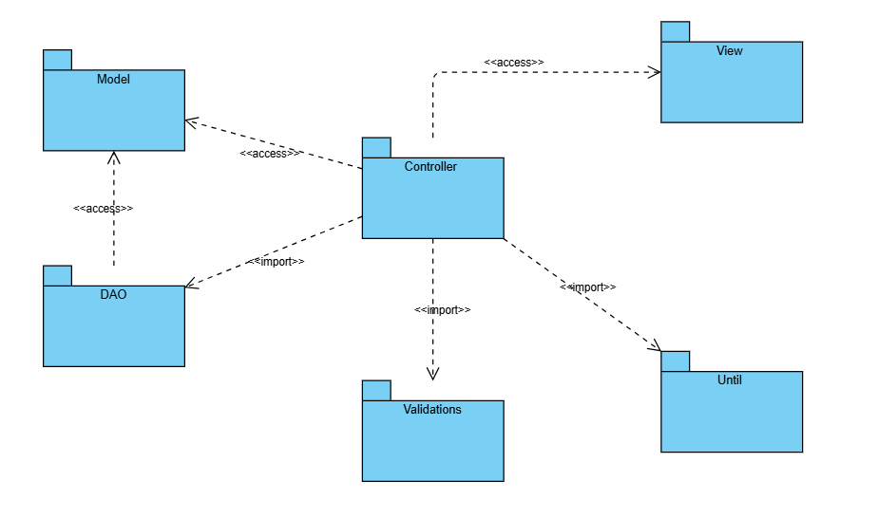

### 2.2 Package Descriptions

|  |  |  |
| --- | --- | --- |
| **No** | **Package** | **Description** |
| 01 | Controller | Handles user requests, processes business logic, and interacts with DAO to retrieve and update data. It also forwards responses to the View. |
| 02 | Model | Defines data structures (entities) used throughout the application. These objects represent database tables. |
| 03 | DAO | Contains classes responsible for performing CRUD operations on the database. Manages database connections and queries, providing a structured way to handle data transactions. |
| 04 | View | Represents the front-end user interface, displaying data received from the Controller. Uses JSP to dynamically render content. |
| 05 | Validations | Contains validation logic to ensure data integrity before processing ( checking user input, form validation). |
| 06 | Ultil | Provides helper functions and reusable components, such as date formatting, encryption, and logging. |